SE2030 - Software Engineering
Lab Sheet 03 - Use Case Diagram
Group Report

Group Details
Group ID | 2026-Y2-S1-MLB-WEB3G2-44
Topic Name | Web-based Recruitment Company System
Module | SE2030 Software Engineering
Lab | Lab 03 - Use Case Diagram

Group Members
No. | Name / Registration Number | Assigned Use Case (Section 4)
1 | Kokulavasan G - IT23601710 | Apply for Job
2 | Kokulavasan G - IT23601710 | Post Vacancy
3 | Kokulavasan G - IT23601710 | Approve Job Posting
4 | Kokulavasan G - IT23601710 | Approve Employer Registration
5 | Kokulavasan G - IT23601710 | Submit Interview Feedback
6 | Kokulavasan G - IT23601710 | Generate Invoice

System Overview
The Web-based Recruitment Company System allows job seekers to build profiles and apply for jobs online, employers to post vacancies and select candidates, and recruiters to verify postings and match candidates. Administrators, interview panel members and finance officers support the process through user management, interview evaluation and billing of placement fees. This report models the system's functions and users with a UML use case diagram and describes one use case per member in detail.

Actors
Actor | Role in the System
Job Seeker | Registers, maintains a profile and CV, searches and applies for jobs, tracks applications.
Employer | Registers the company, posts vacancies, reviews and shortlists applicants, schedules interviews, views analytics.
Recruiter | Approves job postings, manages the candidate database, matches candidates to vacancies, sends notifications.
System Administrator | Manages users and roles, approves employer registrations, generates reports, configures settings and backups.
Interview Panel Member | Views interview schedules and candidate profiles, submits interview feedback.
Finance Officer | Generates invoices, records payments, tracks outstanding payments, views revenue reports.

Use Case Diagram
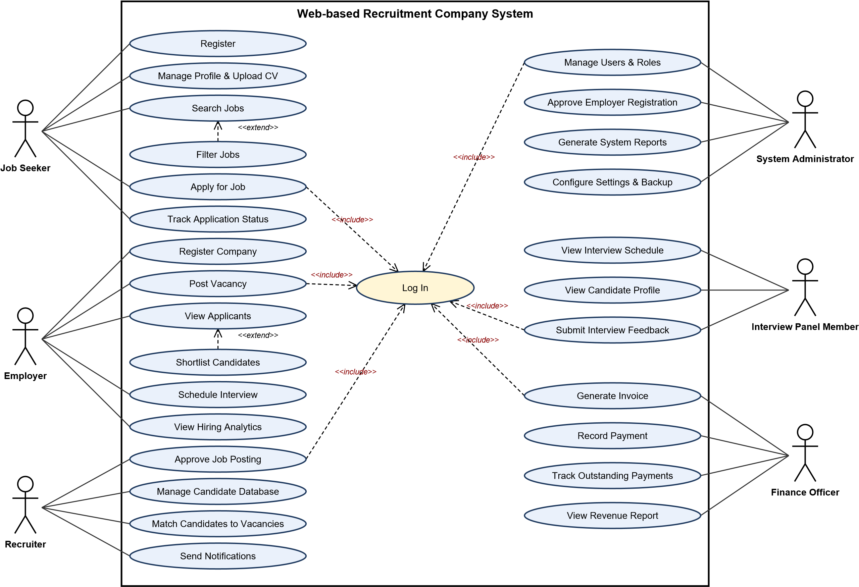
Solid lines: associations. Dashed arrows: <<include>> (all authenticated functions include Log In) and <<extend>> (optional behaviour). Editable version: UCD_2026-Y2-S1-MLB-WEB3G2-44.drawio (open in draw.io).
SE2030 - Lab 03 | Group 2026-Y2-S1-MLB-WEB3G2-44 | Web-based Recruitment Company System Page 2

Use Case List
ID | Use Case | Primary Actor | Relationship
UC-01 | Log In | All registered users | Included by other use cases
UC-02 | Register | Job Seeker
UC-03 | Manage Profile & Upload CV | Job Seeker
UC-04 | Search Jobs | Job Seeker
UC-05 | Filter Jobs | Job Seeker | <<extend>> Search Jobs
UC-06 | Apply for Job | Job Seeker | <<include>> Log In
UC-07 | Track Application Status | Job Seeker
UC-08 | Register Company | Employer
UC-09 | Post Vacancy | Employer | <<include>> Log In
UC-10 | View Applicants | Employer
UC-11 | Shortlist Candidates | Employer | <<extend>> View Applicants
UC-12 | Schedule Interview | Employer
UC-13 | View Hiring Analytics | Employer
UC-14 | Approve Job Posting | Recruiter | <<include>> Log In
UC-15 | Manage Candidate Database | Recruiter
UC-16 | Match Candidates to Vacancies | Recruiter
UC-17 | Send Notifications | Recruiter
UC-18 | Manage Users & Roles | System Administrator | <<include>> Log In
UC-19 | Approve Employer Registration | System Administrator
UC-20 | Generate System Reports | System Administrator
UC-21 | Configure Settings & Backup | System Administrator
UC-22 | View Interview Schedule | Interview Panel Member
UC-23 | View Candidate Profile | Interview Panel Member
UC-24 | Submit Interview Feedback | Interview Panel Member | <<include>> Log In
UC-25 | Generate Invoice | Finance Officer | <<include>> Log In
UC-26 | Record Payment | Finance Officer
UC-27 | Track Outstanding Payments | Finance Officer
UC-28 | View Revenue Report | Finance Officer

Individual Use Case Scenarios
Each member has written one comprehensive use case scenario for the function assigned to them.

UC-06: Apply for Job
Written by | Member 1 - Kokulavasan G - IT23601710
Use Case ID / Name | UC-06 - Apply for Job
Primary Actor | Job Seeker
Supporting Actors | Employer (receives application), Email Service
Description | A registered job seeker applies online for a published vacancy using his/her stored profile and  CV, so that the application reaches the employer and recruiter without any manual paperwork.
Preconditions | - The job seeker has a registered and active account and is logged in (includes Log In).  - The job seeker's profile is complete and at least one CV is uploaded.  - The selected vacancy is published and its closing date has not passed.
Trigger | The job seeker clicks Apply Now on a job details page.
Main Flow (Basic  Path) | - The job seeker opens the details page of a vacancy and selects Apply Now.  - The system confirms the user is logged in and that the profile is complete.  - The system displays the application form pre-filled with the profile details, the default CV andan optional cover letter box.  - The job seeker reviews the details, optionally selects a different CV or uploads a new one, andwrites a cover letter.  - The job seeker selects Submit Application.  - The system validates mandatory fields, CV file type/size, the closing date and that the userhas not already applied.  - The system saves the application with the status Submitted and a timestamp.  - The system emails a confirmation to the job seeker and adds the application to the employer'sand recruiter's applicant lists.  - The system shows a confirmation page with an application reference number and a link toTrack Application Status.
Alternative Flows | 2a. User not logged in: system redirects to the login page and returns to the application after successful login.  2b. Profile incomplete: system prompts the user to complete the missing profile sections first.  5a. Job seeker cancels: system discards the form and returns to the job details page.  6a. Validation fails: system highlights the errors and keeps the entered data.  6b. Already applied: system informs the user and shows the existing application status.  6c. Vacancy closed or removed: system informs the user and disables the Apply button.
Exception Flows | - Upload or database failure: system shows an error message, keeps a draft of the form and letsthe user retry.  - Confirmation email fails: application is still saved; system queues the email for retry.
Postconditions | - The application is stored with status Submitted.  - The employer and recruiter can view the application; the job seeker can track it.
Business Rules | - One application per job seeker per vacancy.  - CV must be PDF or DOCX and not larger than 5 MB.  - Applications are not accepted after the closing date.
Relationships | <<include>> Log In

UC-09: Post Vacancy
Written by | Member 2 - Kokulavasan G - IT23601710
Use Case ID / Name | UC-09 - Post Vacancy
Primary Actor | Employer
Supporting Actors | Recruiter (approves the posting), Email Service
Description | An approved employer creates a new job vacancy so that it can be reviewed by the recruiter and published for job seekers.
Preconditions | - The employer's company account is approved and active.  - The employer is logged in (includes Log In).
Trigger | The employer selects Post New Vacancy from the employer dashboard.
Main Flow (Basic  Path) | - The employer selects Post New Vacancy.  - The system displays the vacancy form (job title, description, category, location, employmenttype, salary range, required skills, experience level, number of positions and closing date).  - The employer fills in the details.  - The employer selects Submit for Approval.  - The system validates the mandatory fields and that the closing date is in the future.  - The system saves the vacancy with the status Pending Approval.  - The system notifies the recruiter that a new posting is waiting for review.  - The system displays a confirmation message and the vacancy appears under My Vacancies as Pending.
Alternative Flows | 4a. Employer selects Save as Draft: system saves the vacancy as Draft and it can be completed later.  5a. Validation fails: system shows error messages next to the invalid fields and keeps the data.  5b. Closing date in the past: system asks the employer to enter a valid date.  8a. Employer edits a pending vacancy: system updates it and keeps the status Pending Approval.
Exception Flows | - System or database error: system displays an error message and preserves the entered dataas a draft.  - Session timeout: system asks the employer to log in again and restores the draft.
Postconditions | - A vacancy exists with the status Pending Approval.  - The vacancy is not visible to job seekers until approved.
Business Rules | - Only approved employers may post vacancies.  - All mandatory fields must be completed before submission.  - Every posting must be approved by a recruiter before publishing.
Relationships | <<include>> Log In

UC-14: Approve Job Posting
Written by | Member 3 - Kokulavasan G - IT23601710
Use Case ID / Name | UC-14 - Approve Job Posting
Primary Actor | Recruiter
Supporting Actors | Employer (notified of decision), Email Service
Description | A recruiter reviews a vacancy submitted by an employer and approves, rejects or returns it for changes so that only genuine and appropriate vacancies are published.
Preconditions | - The recruiter is logged in (includes Log In).  - At least one vacancy with the status Pending Approval exists.
Trigger | The recruiter opens the Pending Job Postings list.
Main Flow (Basic  Path) | - The recruiter opens the Pending Job Postings list.  - The system lists pending vacancies with company, title and submitted date.  - The recruiter selects a vacancy to review.  - The system displays the full vacancy details and the employer's verification status.  - The recruiter checks that the content is genuine, complete, non-discriminatory and not aduplicate.  - The recruiter selects Approve.  - The system changes the status to Published and makes the vacancy searchable.  - The system records the action (recruiter, date and time) in the audit log.  - The system emails the employer that the vacancy is live and displays a success message.
Alternative Flows | 6a. Reject: the recruiter selects Reject and enters a reason; the status becomes Rejected and the employer is notified with the reason.  6b. Request changes: the recruiter enters comments; the status becomes Changes Requested and the employer is asked to edit and resubmit.  6c. Duplicate detected: the system warns the recruiter and offers to link or reject the posting.
Exception Flows | • Notification email fails: the decision is still saved and the system retries sending the email. • Concurrent review by another recruiter: the system informs the user that the posting has already been processed.
Postconditions | - The vacancy status is Published, Rejected or Changes Requested.  - The decision is recorded in the audit log and the employer has been notified.
Business Rules | - Only users with the Recruiter role may approve postings.  - A rejection or change request must include a reason.  - Only approved vacancies appear in job search.
Relationships | <<include>> Log In

UC-19: Approve Employer Registration
Written by | Member 4 - Kokulavasan G - IT23601710
Use Case ID / Name | UC-19 - Approve Employer Registration
Primary Actor | System Administrator
Supporting Actors | Employer (applicant), Email Service
Description | The system administrator verifies a company's registration request and approves or rejects it so that only genuine employers can use the recruitment system.
Preconditions | - The administrator is logged in (includes Log In).  - An employer registration request with the status Pending exists.
Trigger | The administrator opens Employer Registration Requests.
Main Flow (Basic  Path) | - The administrator opens the Employer Registration Requests page.  - The system displays the pending requests with company name, business registration number,contact person and date.  - The administrator selects a request.  - The system shows the full company details and uploaded documents.  - The administrator verifies the details against the submitted documents.  - The administrator selects Approve.  - The system activates the employer account and generates a username and temporarypassword.  - The system emails the credentials to the registered contact person.  - The system logs the approval (administrator, date and time) and displays a success message.
Alternative Flows | 6a. Reject: the administrator enters a reason; the status becomes Rejected and the applicant is notified.  6b. More information needed: the administrator requests additional documents; the status becomes On Hold and the applicant is notified.  4a. Duplicate company found: the system warns the administrator and links the existing account.
Exception Flows | - Credential email fails: the account stays active, the system flags the request and offers Resend Credentials.  - Database error: the status is not changed and an error message is shown.
Postconditions | - The employer account is Active (approved) or the request is Rejected/On Hold.  - The action is stored in the audit log and the applicant has been notified.
Business Rules | - Only administrators may approve employer registrations.  - Temporary passwords must be changed at first login.  - Every decision must be logged.
Relationships | <<include>> Log In

UC-24: Submit Interview Feedback
Written by | Member 5 - Kokulavasan G - IT23601710
Use Case ID / Name | UC-24 - Submit Interview Feedback
Primary Actor | Interview Panel Member
Supporting Actors | Recruiter and Employer (view feedback), Email Service
Description | An interview panel member records scores and comments for a candidate after an interview so that hiring decisions are fair, consistent and documented.
Preconditions | - The panel member is logged in (includes Log In).  - The panel member is assigned to the interview and the interview time has passed.
Trigger | The panel member selects a completed interview from My Interviews.
Main Flow (Basic  Path) | - The panel member opens My Interviews and selects a completed interview.  - The system displays the candidate summary and the evaluation form.  - The panel member rates each criterion (technical skills, communication, problem solving,cultural fit) from 1 to 5.  - The panel member enters comments and selects a recommendation (Hire, Hold or Reject).  - The panel member selects Submit Feedback.  - The system validates that all mandatory ratings and the recommendation are provided.  - The system saves the feedback and marks the interview as Feedback Completed.  - The system notifies the recruiter and employer that feedback is available.  - The system displays a confirmation message.
Alternative Flows | 5a. Save draft: the system stores the form as a draft and it can be completed later.  2a. Candidate did not attend: the panel member marks No Show; scoring is skipped and the recruiter is notified.  6a. Validation fails: the system highlights the missing fields.  9a. Edit request: the panel member may edit the feedback within 24 hours of submission.
Exception Flows | - System error while saving: the entered data is preserved as a draft and the user is asked toretry.  - Session timeout: the user logs in again and the draft is restored.
Postconditions | - Feedback is stored against the candidate's interview record.  - The recruiter and employer can view the feedback.
Business Rules | - Only assigned panel members can submit feedback.  - Submitted feedback is read-only after 24 hours.  - Ratings are on a fixed 1-5 scale.
Relationships | <<include>> Log In

UC-25: Generate Invoice
Written by | Member 6 - Kokulavasan G - IT23601710
Use Case ID / Name | UC-25 - Generate Invoice
Primary Actor | Finance Officer
Supporting Actors | Employer (receives invoice), Email Service
Description | A finance officer generates an invoice for the placement fee when a candidate has been successfully placed with an employer, so that the recruitment company can collect its income.
Preconditions | - The finance officer is logged in (includes Log In).  - A placement with the status Confirmed exists and has not been invoiced.  - The fee terms (percentage or fixed amount) are defined for the employer.
Trigger | The finance officer selects Placements Ready for Invoicing.
Main Flow (Basic  Path) | - The finance officer opens Placements Ready for Invoicing.  - The system lists confirmed placements that have no invoice.  - The finance officer selects a placement and chooses Generate Invoice.  - The system retrieves the employer, candidate, vacancy and agreed salary details.  - The system calculates the placement fee and taxes and creates a draft invoice with an invoicenumber, issue date and due date.  - The finance officer reviews the draft and applies any approved adjustment or discount.  - The finance officer selects Confirm and Issue.  - The system generates the invoice as a PDF, stores it and sets the status to Issued.  - The system emails the invoice to the employer and adds it to the outstanding payments list.  - The system records the action in the audit log and displays a success message.
Alternative Flows | 5a. Fee terms missing: the system asks the finance officer to enter the fee manually and records the change.  6a. Cancel: the finance officer discards the draft and the placement remains uninvoiced. 9a. Email delivery fails: the invoice stays Issued and the system offers Resend Invoice.
Exception Flows | - PDF generation fails: the system shows an error and keeps the draft so that it can beregenerated.  - Invoice already exists for the placement: the system blocks duplicate creation and shows theexisting invoice.
Postconditions | - An invoice with the status Issued is stored and linked to the placement.  - The amount appears in the outstanding payments list.
Business Rules | - One invoice per confirmed placement.  - Only users with the Finance Officer role can issue invoices.  - Fee adjustments must be recorded in the audit log.
Relationships | <<include>> Log In

